DAY 2: NETWORK TOPOLOGIES THEORY
- Draw a diagram of a bus topology and label all key components, then write one real-world example where this topology might be used.
Answer
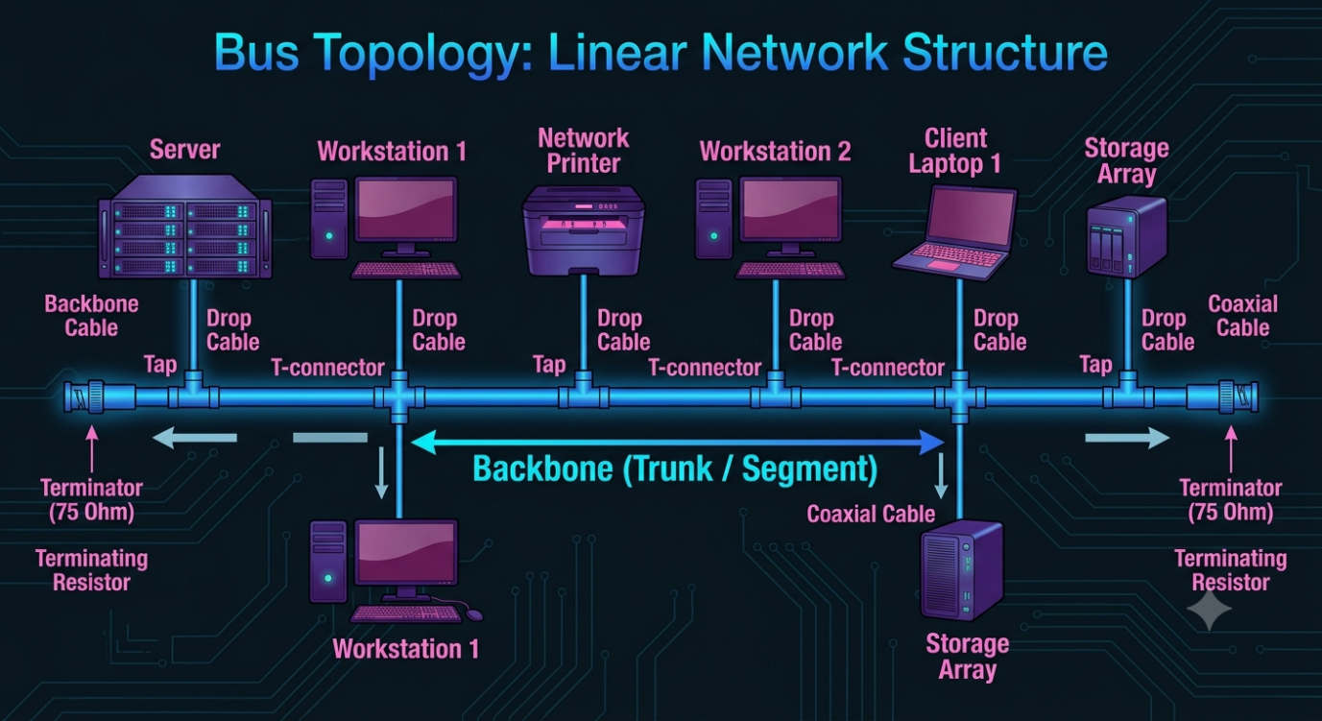
Real-world Example of a Bus Topology:
A common real-world application of a physical bus topology is in industrial control systems using Controller Area Network (CAN) technology.
In a modern automobile, a high-speed CAN bus acts as the central backbone connecting various Electronic Control Units (ECUs) (the "nodes" in the diagram), such as the engine control module, the transmission controller, and the anti-lock brake system (ABS). These units are daisy-chained along the bus cable, and data is transmitted to all modules on the single trunk, which is terminated at both ends to prevent signal reflection.

- In Cisco Packet Tracer, create a simple star topology with one switch and four PCs connected to it; name each PC after a popular app (e.g., WhatsApp, Zomato, Spotify, Flipkart) and take a screenshot of your topology.
Answer
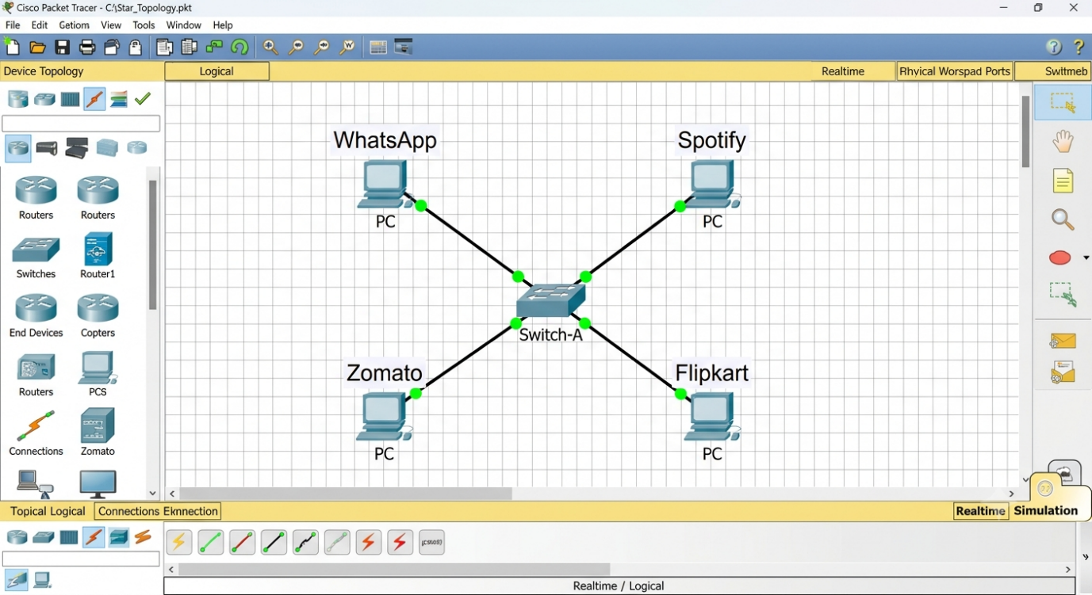

- Draw a ring topology diagram and explain in 2-3 sentences how data travels between devices in this setup. Use arrows to show the direction of data flow.
Answer
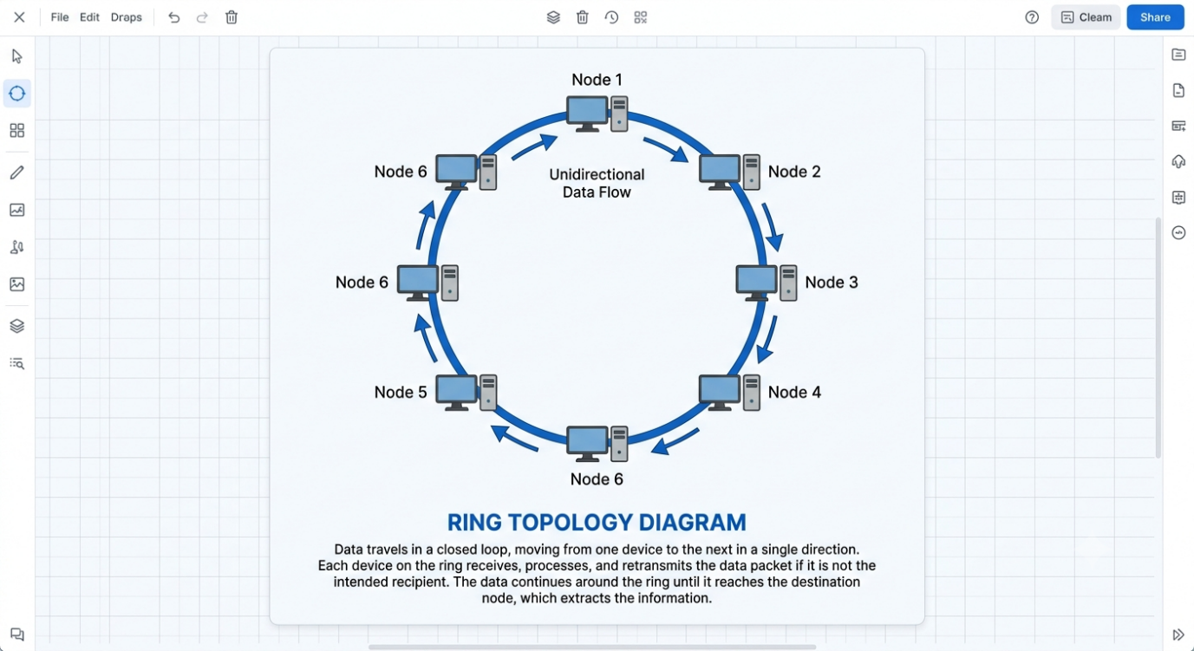

- Compare mesh and star topologies by listing 2 advantages and 2 disadvantages of each in a table format.
Answer
